TREAT FOR MOSQUITOES

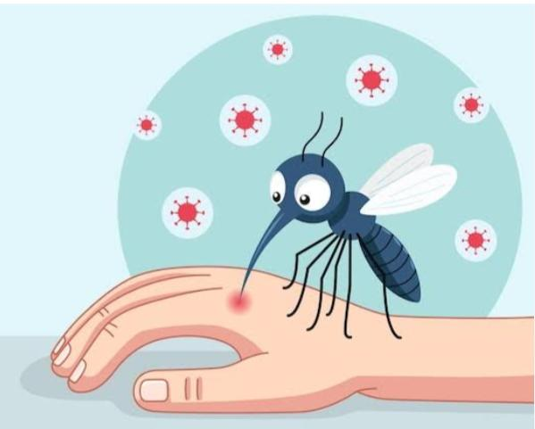
- Look at the picture below and answer the questions:

Q1 What insect is shown in the picture?
- Where do mosquitoes lay their eggs?
- Why are mosquitoes harmful to humans?
- Name one disease caused by mosquitoes.
- How can we stop mosquitoes from breeding near our homes?

Ans by own

- While returning to home from school Reshma saw some people from her local Municipality are releasing guppy fish in the drains and canals. Why?
Ans- It is because some types of fish eat mosquito larvae, which can prevent mosquitoes from breeding . By eating the larvae, the fishes prevent mosquitoes from growing up and spreading diseases. It’s a natural way to keep the mosquito numbers down without using chemicals
[** Sometimes kerosene oil is also spread on the water surface as oil forms a barrier on water thereby suffocating and killing mosquito larvae]
Q3. A pond with clear water was covered up with a green algae within a week near the school.
  - What are algae?
Ans - Algae are simple, plant-like organisms that are mostly found in water. They are photosynthetic
Algae are very important because they make much of Earth’s oxygen.
  - Where and when are they commonly seen?
Ans by own

4.Nitu has been feeling extremely tired for the past few days. After consulting his personal physician, he was advised to undergo a blood test. The results showed that his haemoglobin level is 9 gm/dL, which is below the normal range.
A. Nitu was suffering from which disease.
B. What specific food items would a doctor recommend to Nitu for a quick recovery?
Ans by own
Ans- Anaemia is a condition in which the number of red blood cells or the haemoglobin concentration within them is lower than normal. It can make people feel very tired and weak because in such a case blood doesn’t have enough red blood cells to carry oxygen to their body parts.

5.Give examples of diseases spread by housefly. How do they spread disease?
Houseflies can contaminate food and water by landing on them and depositing pathogens. They vomit and defecate on the food, leaving behind disease-causing microorganisms. When humans consume the contaminated food or water, they become infected with the pathogens and fall ill.
Examples are cholera, typhoid, dysentery etc

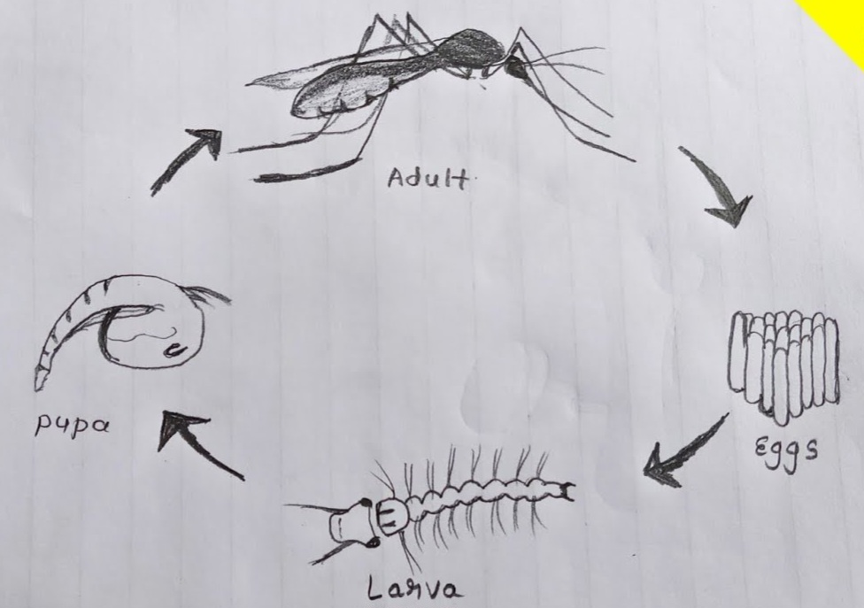
6.Draw the life cycle of mosquito

